
Marking key Task Four: Heart Dissection (22 marks)

Method:

Heart measurement

Description | Mark
Measurement with units | 1
 | /1

- What is the purpose of these valves?

Description | Mark
Keeps blood flowing in one direction/ stop backflow of blood | 1
 | /1

- What is different about the left ventricle compared with the right ventricle?

Description | Mark
Left ventricle is thicker than the right | 1
 | /1

Questions:

- Label the following diagram of the heart. Label the diagram of the heart and use arrows to show the flow of deoxygenated blood and oxygenated blood through the heart

Description | Mark
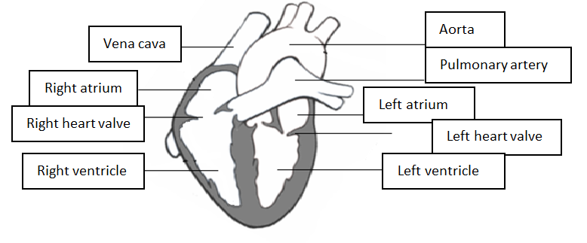 | 9
Correct labelling of deoxygenated and oxygenated blood | 1
 | /10

- Where does the blood from the right atrium come from?

Description | Mark
Body | 1
 | /1

- Where does the blood from the right ventricle go to?

Description | Mark
Lungs | 1
 | /1

- Where does the blood from the left atrium come from?

Description | Mark
Lungs | 1
 | /1

- Where does the blood from the left ventricle go to?

Description | Mark
Body | 1
 | /1

- The heart is known as a double pump. Explain why it is known as a double pump.

Description | Mark
First pump- blood moves from atria to ventricles | 1
Second pump- blood goes from ventricles to lungs and body | 2
 | /3

